Acceptance test
Button tool suggestions statistics
Acceptance criteria
Input a file and run statistics, and the suggestions section should appear, recommending the appropriate tool for DNA and protein.
User opens the main program
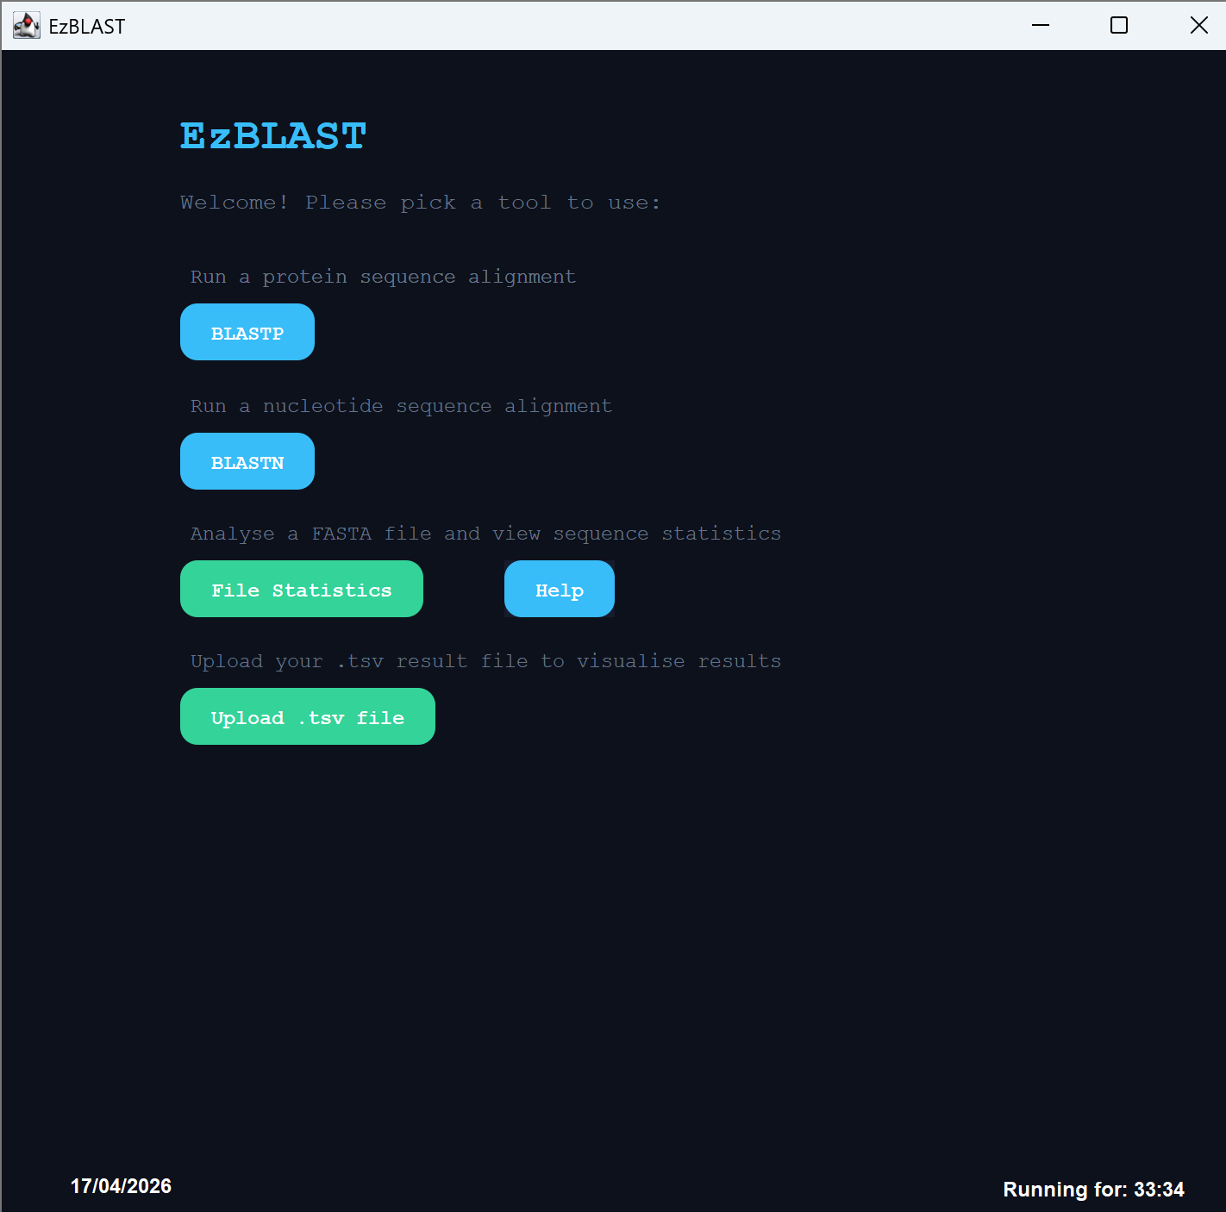
The user selects file statistics button and selects their file
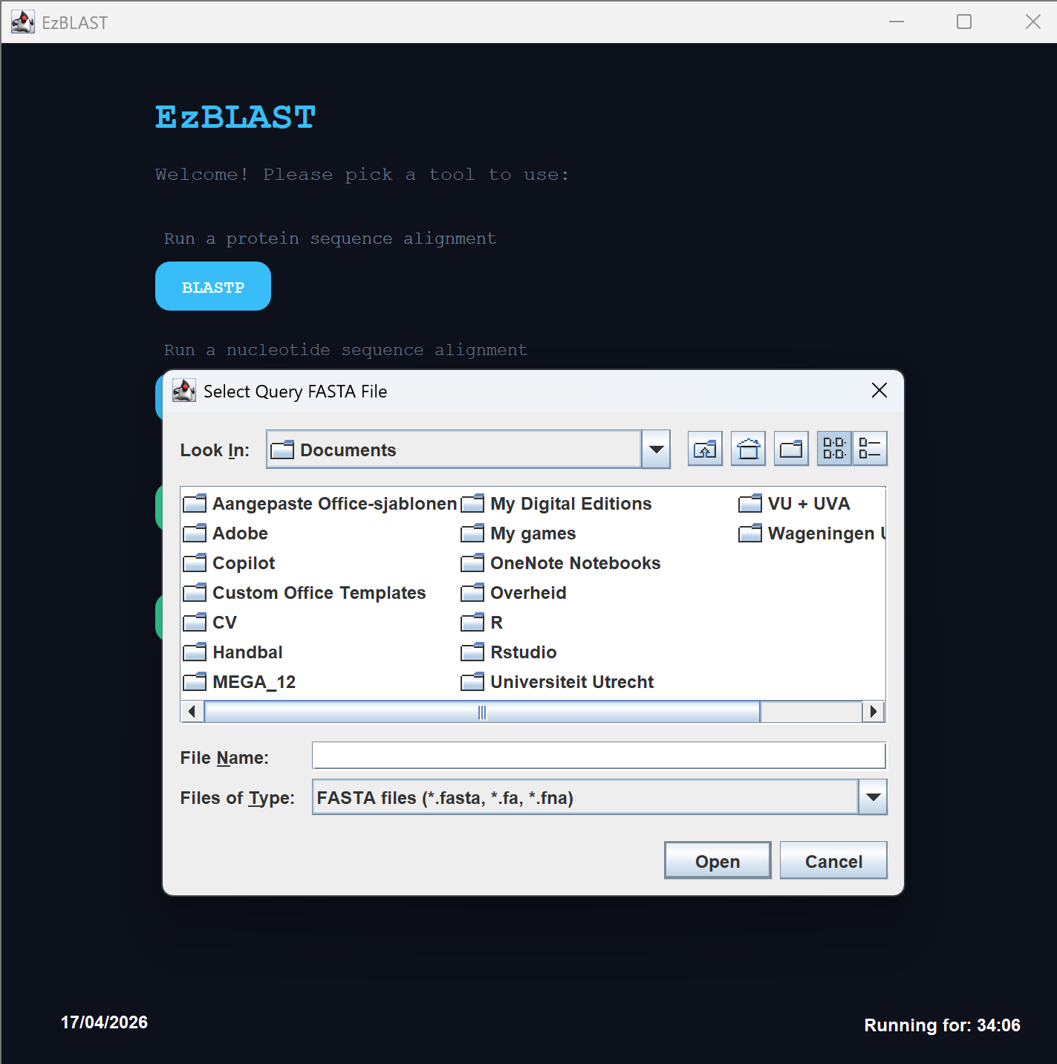
The right column suggests to use BLASTN. That is correct, as BLASTN runs the BLAST algorithm for nucleotide sequences, and the file provided contains a nucleotide sequence. The user presses the BLASTN button.
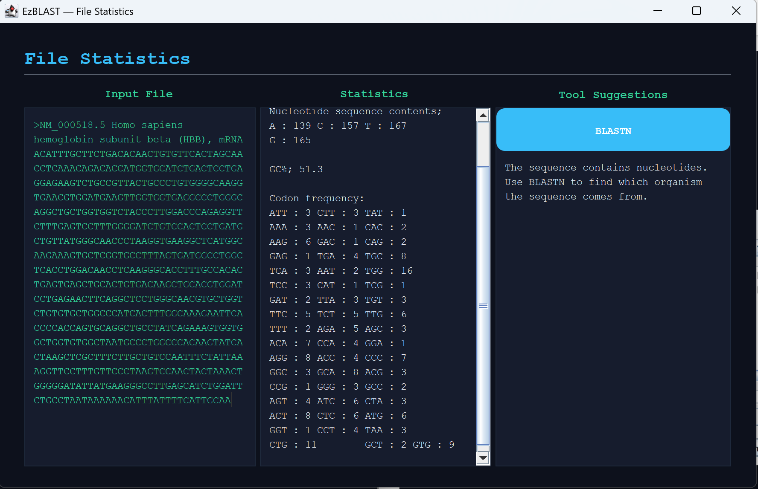
And finds themselves on the BLASTN page.
